**Write a JSF project which contains 1 web page which is called *index.xhtml*, and contains a table as shown.**

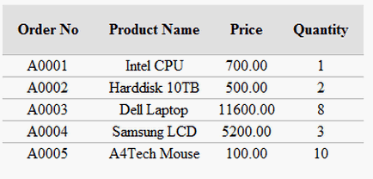

You must do the following

1. Create a class called Order.java with 4 attributes: ‘Order No’(String), ‘Product Name’(String), ‘Price’(int), and ‘Quantity’(int).
2. Create a managed bean called OrderBean.java with an array called orders of the class Order.java.
3. Initialize the array with the data in the figure.
4. Write the index.xhtml page which show the table using <h:dataTable> tag.